### **Multiple-Choice Questions (MCQs):**

JavaScript Fundamentals:

What does the typeof operator return when used with typeof 42?

A) number

B) string

C) object

D) undefined

**ANS:A**

Which keyword is used to declare a variable in JavaScript?

A) var

B) int

C) let

D) const

**ANS:C,D**

What is the result of "5" + 2 in JavaScript?

A) "52"

B) 7

C) "7"

D) Error

**ANS:A**

How do you comment a single line in JavaScript?

A) // This is a comment

B) <!-- This is a comment -->

C) /* This is a comment */

D) # This is a comment

**ANS:A**

Which function is used to display a message in a popup box in JavaScript?

A) alert()

B) confirm()

C) prompt()

D) console.log()

**ANS:A**

What will be the output of console.log(3 === '3') in JavaScript?

A) true

B) false

C) undefined

D) Error

**ANS:B**

How do you declare a function in JavaScript?

A) function myFunction() {}

B) def myFunction():

C) void myFunction() {}

D) function = myFunction() {}

**ANS:A**

What is the correct way to include an external JavaScript file named script.js in an HTML document?

A) <script href="script.js"></script>

B) <script src="script.js"></script>

C) <script include="script.js"></script>

D) <script import="script.js"></script>

**ANS:B**

Which loop is used for iterating over the properties of an object in JavaScript?

A) for loop

B) while loop

C) do-while loop

D) for...in loop

**ANS:D**

What is the result of NaN === NaN in JavaScript?

A) true

B) false

C) undefined

D) Error

**ANS:B**

Bootstrap Basics:

Which CSS framework is Bootstrap built on top of?

A) Sass

B) Less

C) CSS

D) None of the above

**ANS:A**

Which class is used to create a responsive navigation bar in Bootstrap?

A) .navbar-fixed

B) .navbar-responsive

C) .navbar-expand

D) .navbar

**ANS:C**

How do you create a grid layout in Bootstrap?

A) Using <table> tags

B) Using <div> tags with custom CSS

C) Using .container and .row classes

D) Using inline CSS styles

**ANS:C**

Which class is used to create a responsive image in Bootstrap?

A) .img-fluid

B) .responsive-img

C) .img-responsive

D) .fluid-image

**ANS:A**

How do you create a button in Bootstrap with rounded corners?

A) .btn

B) .btn-primary

C) .btn-rounded

D) .btn-rounded-corners

**ANS:A**

Which grid class is used to create a full-width column in Bootstrap?

A) .col-md-12

B) .col-sm-12

C) .col-lg-12

D) .col-12

**ANS:D**

How do you create a modal dialog in Bootstrap?

A) Using <dialog> tags

B) Using <div> tags with custom CSS

C) Using .modal and .modal-dialog classes

D) Using JavaScript alert() function

**ANS:C**

Which class is used to create a dropdown menu in Bootstrap?

A) .dropdown-toggle

B) .dropdown-menu

C) .dropdown

D) .drop-menu

**Ans:B**

How do you create a responsive table in Bootstrap?

A) Using <table> tags with custom CSS

B) Using .table and .table-responsive classes

C) Using <div> tags with inline styles

D) Using JavaScript to dynamically adjust table size

**ANS:B**

Which class is used to create a carousel (image slider) in Bootstrap?

A) .carousel-item

B) .carousel-slide

C) .slider

D) .carousel

Answer: D) .carousel

**ANS:D**

### **Exercise Questions:**

Create a simple JavaScript program that prompts the user to enter two numbers, then displays their sum in an alert box.

<!DOCTYPE html>

<html lang="en">

<head>

  <meta charset="UTF-8">

  <meta name="viewport" content="width=device-width, initial-scale=1.0">

  <title>Document</title>

</head>

<body>

  <script>

const firstNumber = parseFloat(prompt("Enter the first number:"));

const secondNumber = parseFloat(prompt("Enter the second number:"));

const sum = firstNumber + secondNumber;

alert(`The sum of ${firstNumber} and ${secondNumber} is ${sum}.`);

  </script>

</body>

</html>

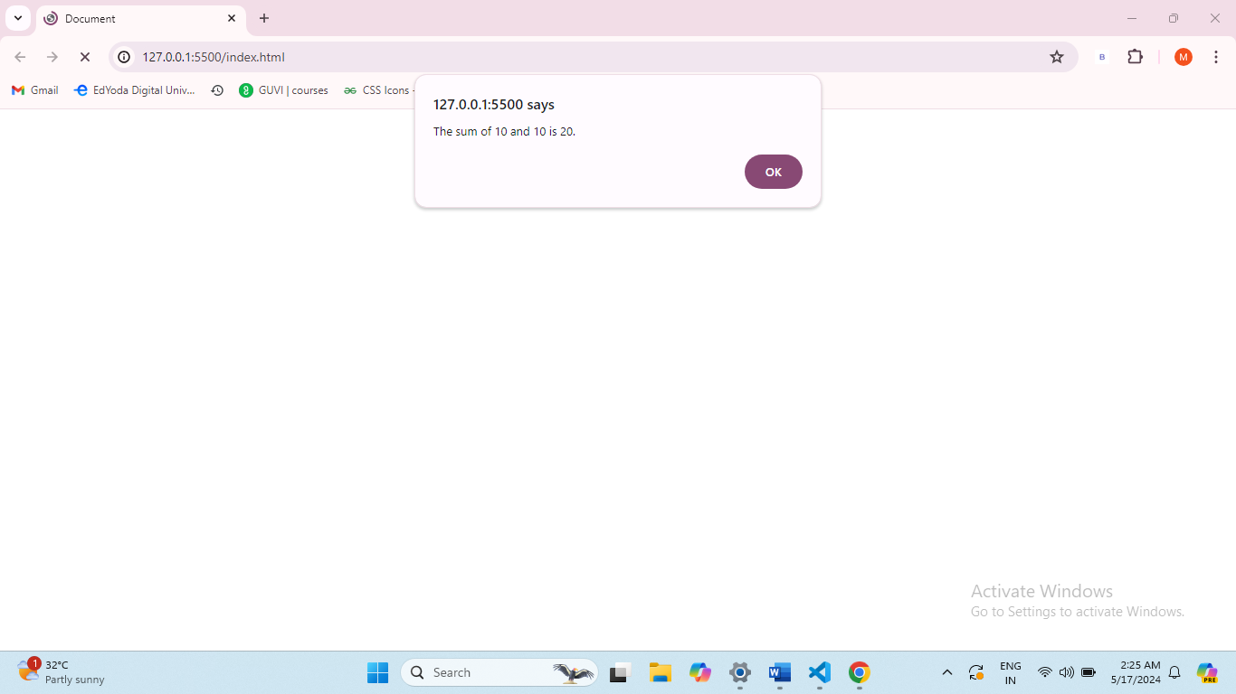

Develop a JavaScript function that takes a Celsius temperature as input and converts it to Fahrenheit, then logs the result to the console.

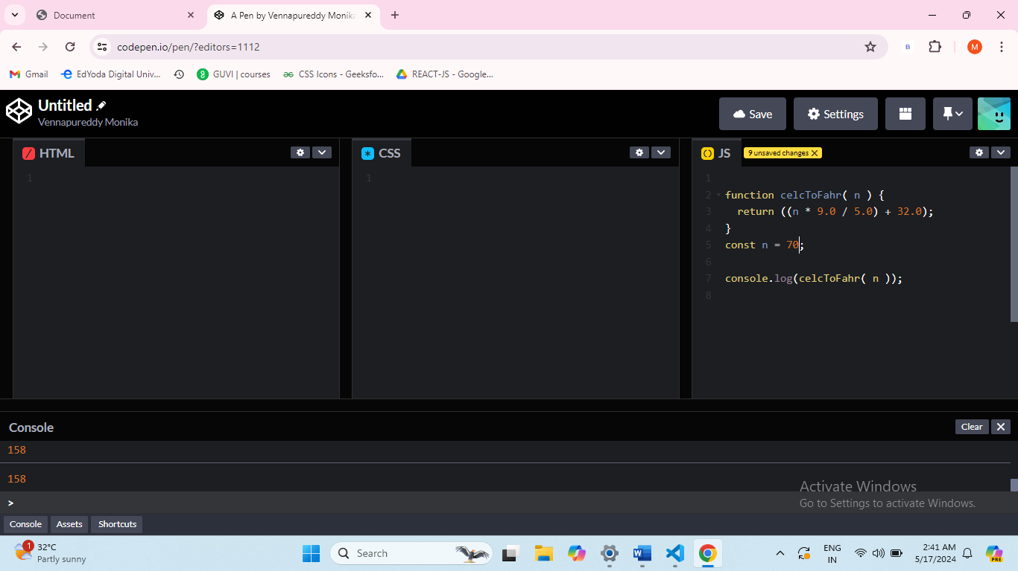

Build a basic Bootstrap webpage with a responsive navigation bar (navbar), a Jumbotron (jumbotron), and a grid layout (container and row).

<!DOCTYPE html>

<html lang="en">

<head>

    <meta charset="UTF-8">

    <meta name="viewport" content="width=device-width, initial-scale=1.0">

    <title>My Bootstrap Page</title>

    <link rel="stylesheet" href="https://stackpath.bootstrapcdn.com/bootstrap/4.5.2/css/bootstrap.min.css">

</head>

<body>

    <script src="https://code.jquery.com/jquery-3.5.1.slim.min.js"></script>

<script src="https://cdn.jsdelivr.net/npm/@popperjs/core@2.11.6/dist/umd/popper.min.js"></script>

<script src="https://stackpath.bootstrapcdn.com/bootstrap/4.5.2/js/bootstrap.min.js"></script>

<nav class="navbar navbar-expand-lg navbar-light bg-light">

    <a class="navbar-brand" href="#">My Website</a>

    <button class="navbar-toggler" type="button" data-toggle="collapse" data-target="#navbarNav"

            aria-controls="navbarNav" aria-expanded="false" aria-label="Toggle navigation">

        <span class="navbar-toggler-icon"></span>

    </button>

    <div class="collapse navbar-collapse" id="navbarNav">

        <ul class="navbar-nav ml-auto">

            <li class="nav-item active">

                <a class="nav-link" href="#">Home <span class="sr-only">(current)</span></a>

            </li>

            <li class="nav-item">

                <a class="nav-link" href="#">About</a>

            </li>

            <li class="nav-item">

                <a class="nav-link" href="#">Services</a>

            </li>

            <li class="nav-item">

                <a class="nav-link" href="#">Contact</a>

            </li>

        </ul>

    </div>

</nav>

<div class="jumbotron">

    <div class="container">

        <h1 class="display-4">Welcome to My Website</h1>

        <p class="lead">This is a simple Bootstrap webpage with a responsive navbar and a Jumbotron.</p>

    </div>

</div>

<div class="container">

    <div class="row">

        <div class="col-md-4">

            <h2>Column 1</h2>

            <p>Lorem ipsum dolor sit amet, consectetur adipiscing elit.</p>

        </div>

        <div class="col-md-4">

            <h2>Column 2</h2>

            <p>Lorem ipsum dolor sit amet, consectetur adipiscing elit.</p>

        </div>

        <div class="col-md-4">

            <h2>Column 3</h2>

            <p>Lorem ipsum dolor sit amet, consectetur adipiscing elit..</p>

        </div>

    </div>

</div>

</body>

</html>

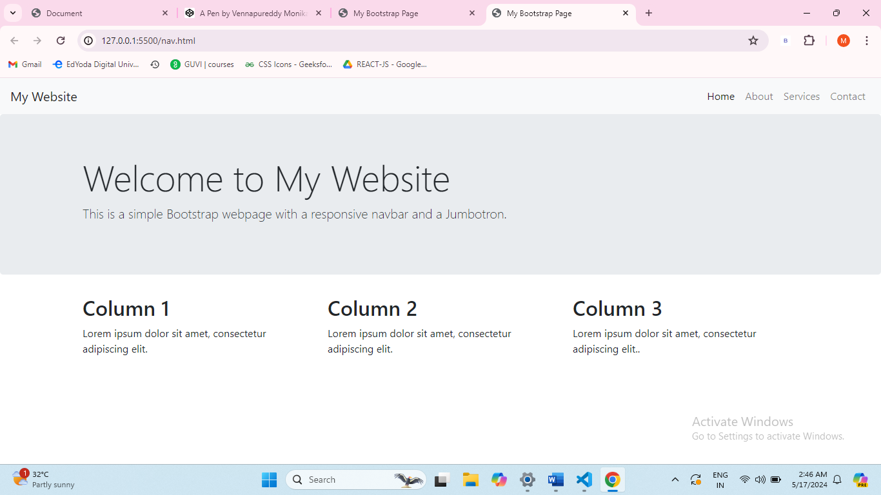

Implement a Bootstrap form with text input fields and a submit button, then use JavaScript to display the entered values in an alert box upon submission.

<!DOCTYPE html>

<html lang="en">

<head>

    <meta charset="UTF-8">

    <meta name="viewport" content="width=device-width, initial-scale=1.0">

    <title>My Form</title>

    <link rel="stylesheet" href="https://stackpath.bootstrapcdn.com/bootstrap/4.5.2/css/bootstrap.min.css">

</head>

<body>

<div class="container mt-5">

    <h2>My Form</h2>

    <form id="myForm">

        <div class="form-group">

            <label for="firstName">First Name:</label>

            <input type="text" class="form-control" id="firstName" placeholder="Enter your first name">

        </div>

        <div class="form-group">

            <label for="lastName">Last Name:</label>

            <input type="text" class="form-control" id="lastName" placeholder="Enter your last name">

        </div>

        <button type="submit" class="btn btn-primary">Submit</button>

    </form>

</div>

<script src="https://code.jquery.com/jquery-3.5.1.slim.min.js"></script>

<script src="https://cdn.jsdelivr.net/npm/@popperjs/core@2.11.6/dist/umd/popper.min.js"></script>

<script src="https://stackpath.bootstrapcdn.com/bootstrap/4.5.2/js/bootstrap.min.js"></script>

<script>

    document.getElementById("myForm").addEventListener("submit", function (event) {

        event.preventDefault();

        const firstName = document.getElementById("firstName").value;

        const lastName = document.getElementById("lastName").value;

        const fullName = `${firstName} ${lastName}`;

        alert(`Hello, ${fullName}! You submitted the form.`);

    });

</script>

</body>

</html>

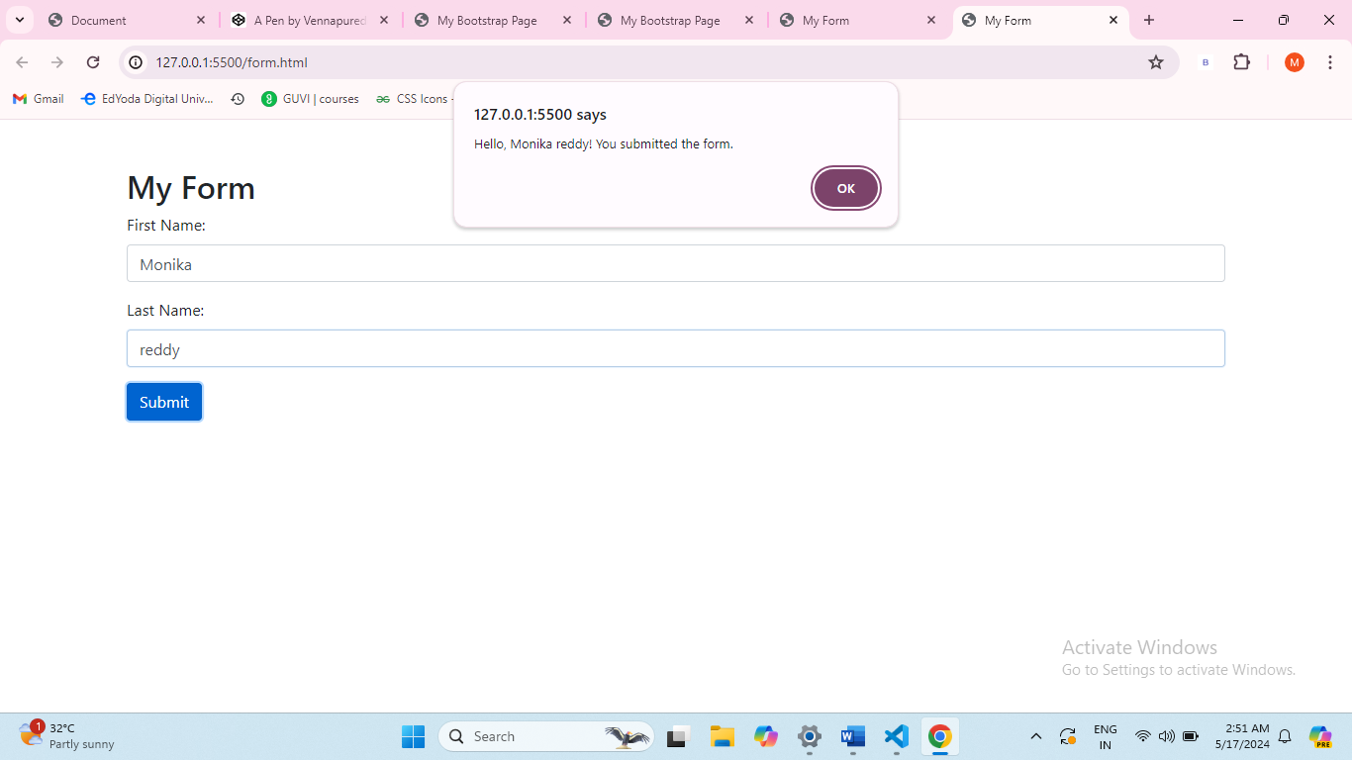

Create a Bootstrap modal dialog that opens when a button is clicked, displaying a message or additional content.

<!DOCTYPE html>

<html lang="en">

<head>

    <meta charset="UTF-8">

    <meta name="viewport" content="width=device-width, initial-scale=1.0">

    <title>Hello</title>

    <link rel="stylesheet" href="https://stackpath.bootstrapcdn.com/bootstrap/4.5.2/css/bootstrap.min.css">

</head>

<body>

    <div class="container mt-5">

        <button type="button" class="btn btn-primary" data-toggle="modal" data-target="#myModal">

            Hello

        </button>

        <div class="modal fade" id="myModal" tabindex="-1" role="dialog" aria-labelledby="exampleModalLabel" aria-hidden="true">

            <div class="modal-dialog" role="document">

                <div class="modal-content">

                    <div class="modal-header">

                        <h5 class="modal-title" id="exampleModalLabel">Welcome</h5>

                        <button type="button" class="close" data-dismiss="modal" aria-label="Close">

                            <span aria-hidden="true">×</span>

                        </button>

                    </div>

                    <div class="modal-body">

                        Welcome to Greemus Technologies

                        Mern Fullstack Javascript developement

                    </div>

                    <div class="modal-footer">

                        <button type="button" class="btn btn-secondary" data-dismiss="modal">Close</button>

                        <button type="button" class="btn btn-primary">Save changes</button>

                    </div>

                </div>

            </div>

        </div>

    </div>

    <script src="https://code.jquery.com/jquery-3.5.1.slim.min.js"></script>

    <script src="https://cdn.jsdelivr.net/npm/@popperjs/core@2.11.6/dist/umd/popper.min.js"></script>

    <script src="https://stackpath.bootstrapcdn.com/bootstrap/4.5.2/js/bootstrap.min.js"></script>

</body>

</html>

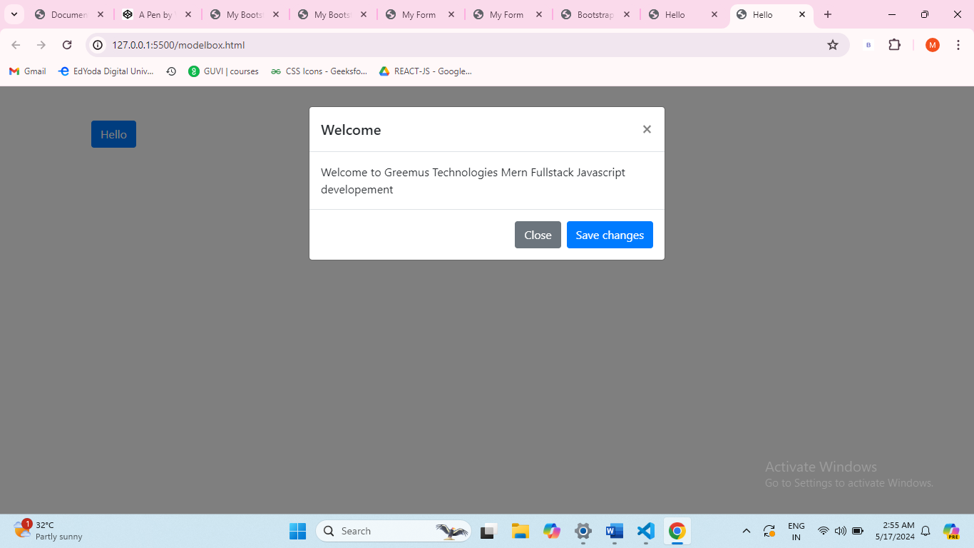

Design a Bootstrap card layout (card) with multiple cards displaying images and text content.

<!DOCTYPE html>

<html lang="en">

<head>

    <meta charset="UTF-8">

    <meta name="viewport" content="width=device-width, initial-scale=1.0">

    <link rel="stylesheet" href="https://stackpath.bootstrapcdn.com/bootstrap/4.5.2/css/bootstrap.min.css">

    <title>Card Layout</title>

</head>

<body>

   <style>

    *{

        background-color: rgb(5, 92, 92);

    }

   </style>

    <div class="container">

        <div class="row">

            <div class="col-md-4">

                <div class="card">

                    <img src="https://tse2.mm.bing.net/th?id=OIP.T5MsS5yKFsEF008b5TfHggHaFP&pid=Api&P=0&h=220" class="card-img-top" alt="Image 1">

                    <div class="card-body">

                        <h5 class="card-title">Python programming language</h5>

                        <p class="card-text">Python is powerful... and fast;

                            plays well with others;

                            runs everywhere;

                            is friendly & easy to learn;

                            is Open.

                            </p>

                    </div>

                </div>

            </div>

            <div class="col-md-4">

                <div class="card">

                    <img src="https://tse3.mm.bing.net/th?id=OIP.mROc8Fv230b7_p5vZuKThgHaEL&pid=Api&P=0&h=220" class="card-img-top" alt="Image 2">

                    <div class="card-body">

                        <h5 class="card-title">React</h5>

                        <p class="card-text">React lets you build user interfaces out of individual pieces called components. Create your own React components like Thumbnail, LikeButton, and Video. Then combine them into entire screens, pages, and apps.</p>

                    </div>

                </div>

            </div>

        </div>

    </div>

    <script src="https://code.jquery.com/jquery-3.5.1.slim.min.js"></script>

    <script src="https://cdn.jsdelivr.net/npm/@popperjs/core@2.11.6/dist/umd/popper.min.js"></script>

    <script src="https://stackpath.bootstrapcdn.com/bootstrap/4.5.2/js/bootstrap.min.js"></script>

</body>

</html>

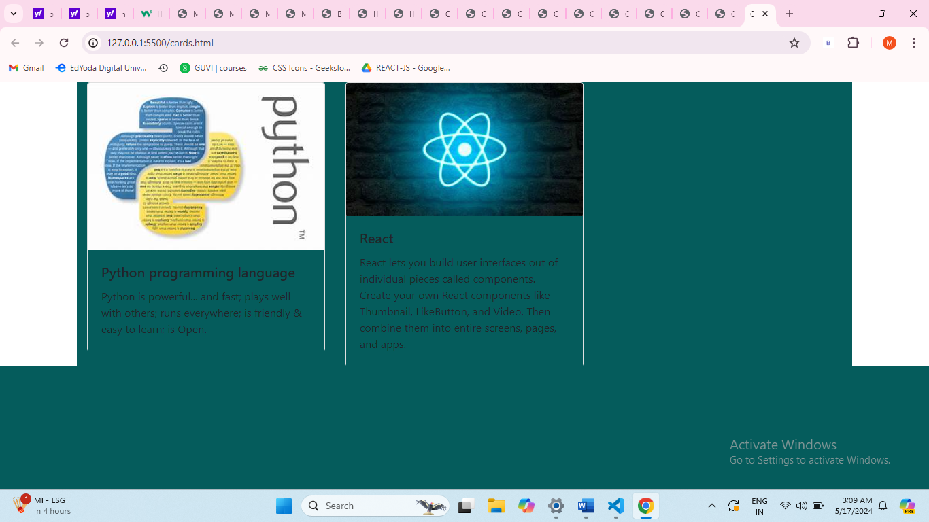

Develop a Bootstrap dropdown menu (dropdown) with multiple menu items that link to different sections or pages.

<!DOCTYPE html>

<html lang="en">

<head>

    <meta charset="UTF-8">

    <meta name="viewport" content="width=device-width, initial-scale=1.0">

    <link rel="stylesheet" href="https://stackpath.bootstrapcdn.com/bootstrap/4.5.2/css/bootstrap.min.css">

    <title>Dropdown Menu</title>

</head>

<body>

    <nav class="navbar navbar-expand-lg navbar-light bg-light">

        <a class="navbar-brand" href="#">My Website</a>

        <button class="navbar-toggler" type="button" data-toggle="collapse" data-target="#navbarNavDropdown" aria-controls="navbarNavDropdown" aria-expanded="false" aria-label="Toggle navigation">

            <span class="navbar-toggler-icon"></span>

        </button>

        <div class="collapse navbar-collapse" id="navbarNavDropdown">

            <ul class="navbar-nav">

                <li class="nav-item dropdown">

                    <a class="nav-link dropdown-toggle" href="#" id="navbarDropdownMenuLink" role="button" data-toggle="dropdown" aria-haspopup="true" aria-expanded="false">

                        Explore

                    </a>

                    <div class="dropdown-menu" aria-labelledby="navbarDropdownMenuLink">

                        <a class="dropdown-item" href="about.html">About</a>

                        <a class="dropdown-item" href="services.html">Services</a>

                        <a class="dropdown-item" href="portfolio.html">Portfolio</a>

                        <div class="dropdown-divider"></div>

                        <a class="dropdown-item" href="contact.html">Contact</a>

                    </div>

                </li>

            </ul>

        </div>

    </nav>

    <script src="https://code.jquery.com/jquery-3.5.1.slim.min.js"></script>

    <script src="https://cdn.jsdelivr.net/npm/@popperjs/core@2.11.6/dist/umd/popper.min.js"></script>

    <script src="https://stackpath.bootstrapcdn.com/bootstrap/4.5.2/js/bootstrap.min.js"></script>

</body>

</html>

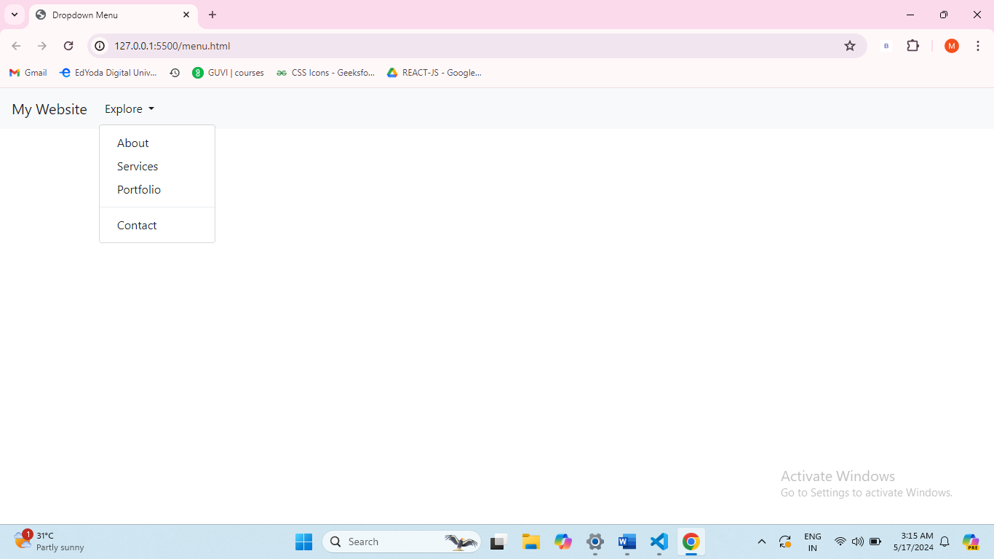

Build a responsive table using Bootstrap (table and table-responsive) to display tabular data.

<!DOCTYPE html>

<html lang="en">

<head>

    <meta charset="UTF-8">

    <meta name="viewport" content="width=device-width, initial-scale=1.0">

    <link rel="stylesheet" href="https://stackpath.bootstrapcdn.com/bootstrap/4.5.2/css/bootstrap.min.css">

    <title>Responsive Table</title>

</head>

<body>

    <div class="container">

        <div class="table-responsive">

            <table class="table table-bordered">

                <thead>

                    <tr>

                        <th scope="col">ID</th>

                        <th scope="col">Name</th>

                        <th scope="col">Age</th>

                        <th scope="col">Email</th>

                    </tr>

                </thead>

                <tbody>

                    <tr>

                        <td>1</td>

                        <td>Monika</td>

                        <td>25</td>

                        <td>abc@example.com</td>

                    </tr>

                    <tr>

                        <td>2</td>

                        <td>Aadhya</td>

                        <td>20</td>

                        <td>abc@example.com</td>

                    </tr>

                    <tr>

                        <td>3</td>

                        <td>Arun</td>

                        <td>30</td>

                        <td>abc@example.com</td>

                    </tr>

                </tbody>

            </table>

        </div>

    </div>

    <script src="https://code.jquery.com/jquery-3.5.1.slim.min.js"></script>

    <script src="https://cdn.jsdelivr.net/npm/@popperjs/core@2.11.6/dist/umd/popper.min.js"></script>

    <script src="https://stackpath.bootstrapcdn.com/bootstrap/4.5.2/js/bootstrap.min.js"></script>

</body>

</html>

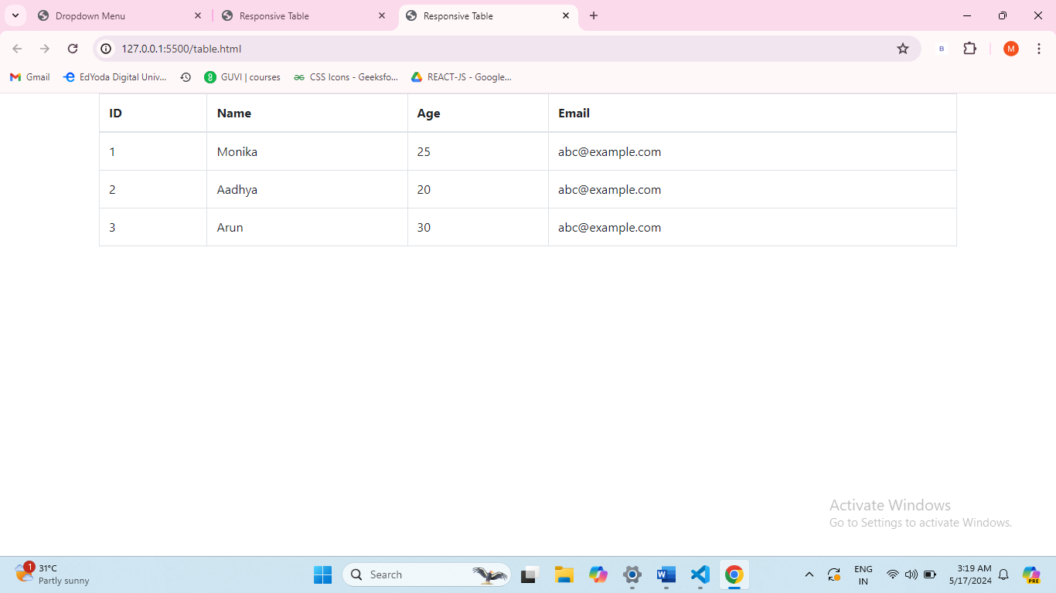

Design a Bootstrap carousel (carousel) with multiple slides/images that automatically cycle through.

<!DOCTYPE html>

<html lang="en">

<head>

  <meta charset="UTF-8">

  <meta name="viewport" content="width=device-width, initial-scale=1.0">

  <link rel="stylesheet" href="bootstrap.css">

  <link rel="stylesheet" href="https://cdn.jsdelivr.net/npm/bootstrap@4.0.0/dist/css/bootstrap.min.css" integrity="sha384-Gn5384xqQ1aoWXA+058RXPxPg6fy4IWvTNh0E263XmFcJlSAwiGgFAW/dAiS6JXm" crossorigin="anonymous">

  <script src="https://code.jquery.com/jquery-3.2.1.slim.min.js" integrity="sha384-KJ3o2DKtIkvYIK3UENzmM7KCkRr/rE9/Qpg6aAZGJwFDMVNA/GpGFF93hXpG5KkN" crossorigin="anonymous"></script>

  <script src="https://cdn.jsdelivr.net/npm/popper.js@1.12.9/dist/umd/popper.min.js" integrity="sha384-ApNbgh9B+Y1QKtv3Rn7W3mgPxhU9K/ScQsAP7hUibX39j7fakFPskvXusvfa0b4Q" crossorigin="anonymous"></script>

  <script src="https://cdn.jsdelivr.net/npm/bootstrap@4.0.0/dist/js/bootstrap.min.js" integrity="sha384-JZR6Spejh4U02d8jOt6vLEHfe/JQGiRRSQQxSfFWpi1MquVdAyjUar5+76PVCmYl" crossorigin="anonymous"></script>

  <title>Document</title>

 <style>

  img{

    height:100vh;

    padding: 100px;

  }

 </style>

</head>

<body>

  <section id="slider" class="carousel slide carousel-fade">

    <div class="carousel-inner">

      <div class="carousel-item active">

        <img class="d-block w-100" src="/javascript/1.jpg" alt="">

      </div>

      <div class="carousel-item">

        <img class="d-block w-100 " src="/javascript/2.jpg" alt="">

      </div>

      <div class="carousel-item">

        <img class="d-block w-100" src="/javascript/3.jpg" alt="">

      </div>

    </div>

    <button class="carousel-control-prev" type="button" data-target="#slider" data-slide="prev">

      <span class="carousel-control-prev-icon"></span>

    </button>

    <button  class="carousel-control-next" type="button" data-target="#slider" data-slide="next">

      <span class="carousel-control-next-icon"></span>

    </button>

  </section>

</body>

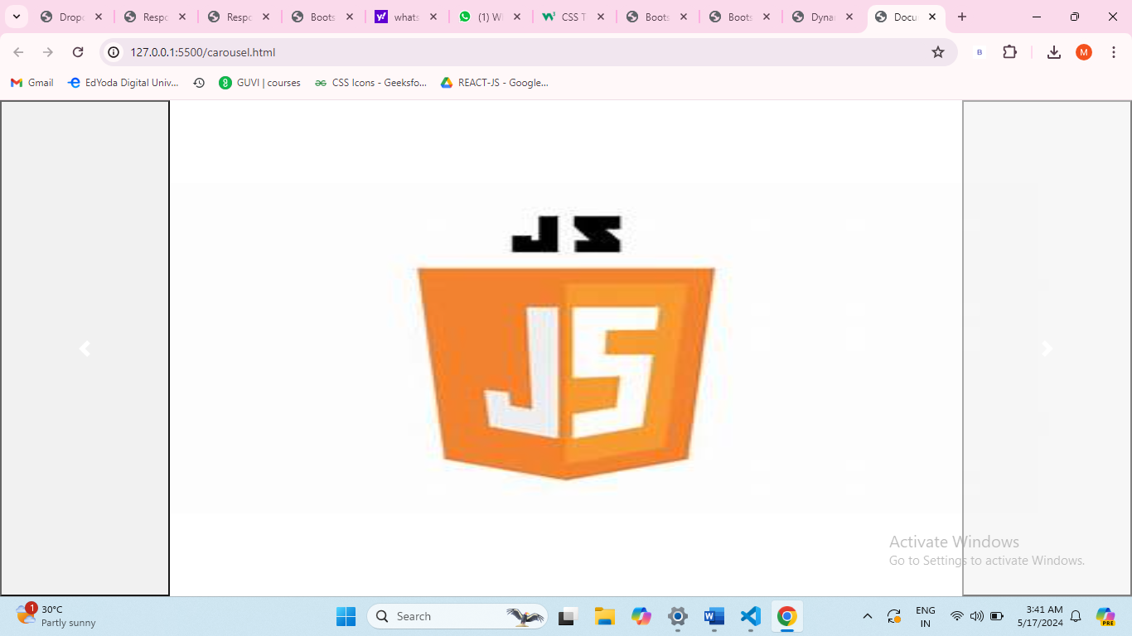

Combine JavaScript and Bootstrap to create a dynamic webpage that updates content based on user interactions (e.g., show/hide elements, change styles).

<!DOCTYPE html>

<html lang="en">

<head>

    <meta charset="UTF-8">

    <meta name="viewport" content="width=device-width, initial-scale=1.0">

    <link rel="stylesheet" href="https://stackpath.bootstrapcdn.com/bootstrap/4.5.2/css/bootstrap.min.css">

    <title>Dynamic Webpage Example</title>

</head>

<body>

    <div class="container mt-5">

        <h1>Greemus Technologies</h1>

        <button id="toggleButton" class="btn btn-primary">Welcome</button>

        <p id="myParagraph" class="mt-3">The greatest challenge in the software development world is to come up with more interactive and high competitive and high quality developments. Greemus software technologies follows a unique process structure that imposed on the software product development Hyderabad.</p>

    </div>

    <script src="https://code.jquery.com/jquery-3.5.1.slim.min.js"></script>

    <script src="https://cdn.jsdelivr.net/npm/@popperjs/core@2.11.6/dist/umd/popper.min.js"></script>

    <script src="https://stackpath.bootstrapcdn.com/bootstrap/4.5.2/js/bootstrap.min.js"></script>

    <script>

        const toggleButton = document.getElementById('toggleButton');

        const myParagraph = document.getElementById('myParagraph');

        toggleButton.addEventListener('click', () => {

            myParagraph.classList.toggle('d-none');

        });

    </script>

</body>

</html>

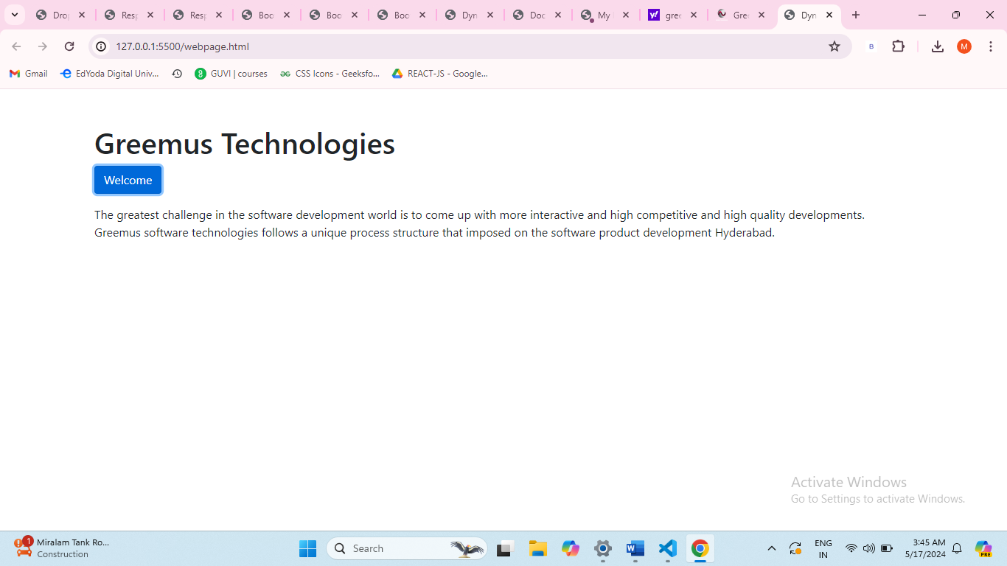

These exercises will help you practice JavaScript fundamentals an